Review 1: Newton’s Universal Gravitation: $F=G\frac{mM}{R^{2}}, G=6.674×{10}^{-11}\frac{N⋅m^{2}}{{kg}^{2}}$

Review 2: Weight and Acceleration due to Gravity: $W=mg, F=G\frac{mM}{R^{2}}$, $g=G\frac{M}{R^{2}}$
Review 3: Orbital Velocity $F_{c}=F_{G}$ , $\frac{mv^{2}}{R}=G\frac{mM_{E}}{R^{2}}$, $v=\sqrt{\frac{GM_{E}}{R}}$
Review 4: Kepler’s Third Law: $\frac{R^{3}}{T^{2}}=\frac{GM}{4π^{2}}$, from $v=\frac{2πR}{T}$ and $v=\sqrt{\frac{GM_{E}}{R}}$

Example 1: The Satellites orbiting around the Earth in circular orbits are examples of uniform circular motion. Each satellite is kept on its circular path by a centripetal force. The gravitational pull of the Earth provides the centripetal force (a) The orbit for satellite A is at a height of 540 km above the Earth’s surface. ${{M_{E}=}^{} 6.0 × {10}^{24}Kg,R}_{E}=6.37×{10}^{6}m,$What is the orbital speed?

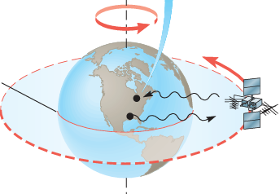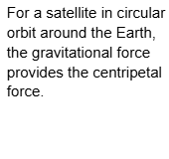

(b) The orbital speed of Satellite 1 is $v_{1}$, and its altitude is ${h_{1}=R}_{E}$ . The orbital speed of Satellite 2 is $v_{2}$, and its altitude is ${h_{2}=1.5R}_{E}$ , find the ratio of $v_{1}/v_{2}$
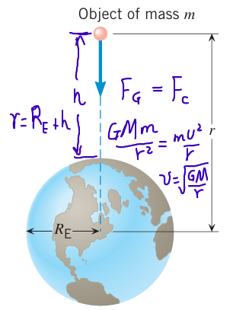

$M_{Sun}=2.0×{10}^{30}kg$, $M_{Earth}=6.0×{10}^{24}kg$, $M_{moon}=7.4×{10}^{22}kg,$ $g=G\frac{M}{R^{2}}$
Example 2 During a lunar eclipse, the Moon, Earth, and Sun all lie on the same line, with the Earth between the Moon and the Sun. The separation between the Moon and the Earth is given by 3.8 × 108 m; the separation between the Earth and the Sun is given by 1.5 × 1011 m.

(a) Calculate the force exerted on Earth by the Moon. (b) Calculate the force exerted on Earth by the Sun.

(c) Calculate the net force exerted on Earth by the Moon and the Sun.

Example 3
2. A 2.10-kg brass ball is transported to the Moon. ( $R_{Moon}=$1.74 × 106 m and $M_{Moon}=$ 7.35 × 1022 kg.)
(a) Calculate the acceleration due to gravity on the Moon.

(b) Determine the mass of the brass ball on Earth and on the Moon.

(c) Determine the weight of the brass ball on Earth.

(d) Determine the weight of the brass ball on Moon.

Example 4: At the surface of Earth, an object of mass m has a weight w. If this object is transported to an altitude twice the radius of the Earth, what is the mass and weight of the object at this new location?

(A) Its mass is m/2, and its weight is w/2
(B) Its mass is m, and its weight is w
(C) Its mass is m/2, and its weight is w/4
(D) Its mass is m, and its weight is w/4
(E) Its mass is m, and its weight is w/9

Orbital Radius and Orbital Period-Kepler’s Third Law

The period T of a satellite is the time required for one orbital revolution. As in any uniform circular motion, the period is related to the speed of the motion by: $v=\frac{2πR}{T}$ , by using the centripetal force is the gravitation we obtian the orbital velocity: $v=\sqrt{\frac{GM}{R}}, Let \frac{2πR}{T}=\sqrt{\frac{GM}{R}}, then \frac{R^{3}}{T^{2}}=\frac{GM}{4π^{2}}$
$\frac{R^{3}}{T^{2}}=\frac{GM}{4π^{2}}$ is the Kepler’s Third Law
Example 5
35. A satellite is in a circular orbit about the Earth (${M_{E}=}^{}$ 6.0 × ${10}^{24}Kg,$ $R_{E}=6.37×{10}^{6}m$). The period of the satellite is $1.2×{10}^{4}s.$What is the speed at which the satellite travels?

Example 6
36. A satellite circles the Earth in an orbit whose radius is twice the Earth’s radius. What is the period of the satellite?

Practice Test:
$F=G\frac{mM}{R^{2}}, G=6.674×{10}^{-11}\frac{N⋅m^{2}}{{kg}^{2}}$ , $v=\sqrt{\frac{GM_{E}}{R}}$, $g=G\frac{M}{R^{2}}$, $\frac{R^{3}}{T^{2}}=\frac{GM}{4π^{2}}$

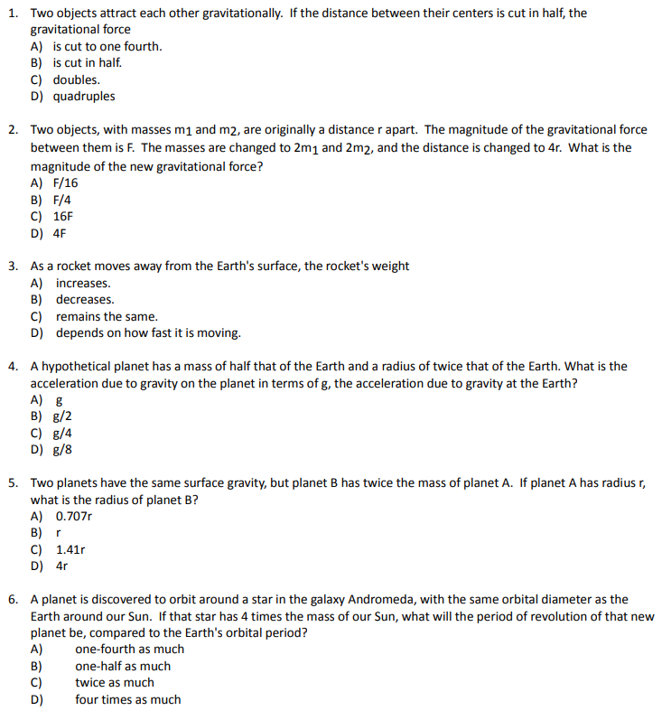

$F=G\frac{mM}{R^{2}}, G=6.674×{10}^{-11}\frac{N⋅m^{2}}{{kg}^{2}}$ , $v=\sqrt{\frac{GM_{E}}{R}}$, $g=G\frac{M}{R^{2}}$, $\frac{R^{3}}{T^{2}}=\frac{GM}{4π^{2}}$

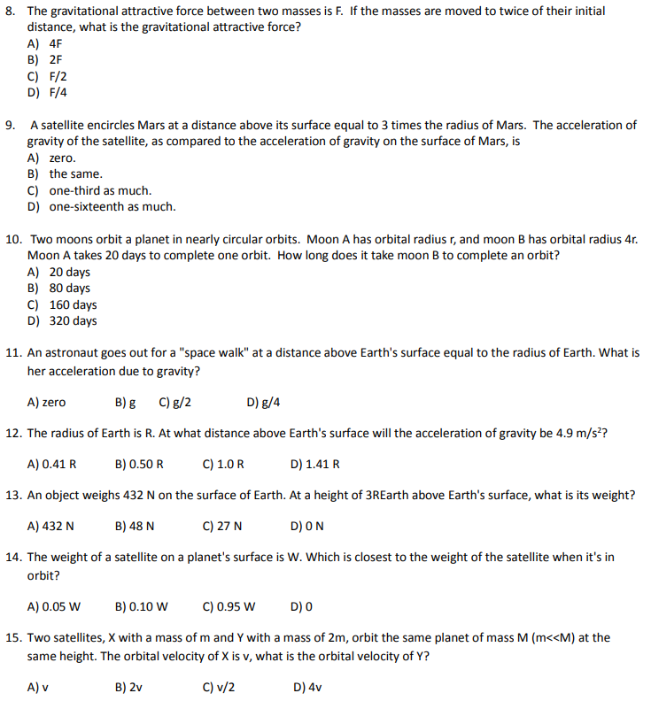

$F=G\frac{mM}{R^{2}}, G=6.674×{10}^{-11}\frac{N⋅m^{2}}{{kg}^{2}}$ , $v=\sqrt{\frac{GM_{E}}{R}}$, $g=G\frac{M}{R^{2}}$, $\frac{R^{3}}{T^{2}}=\frac{GM}{4π^{2}}$
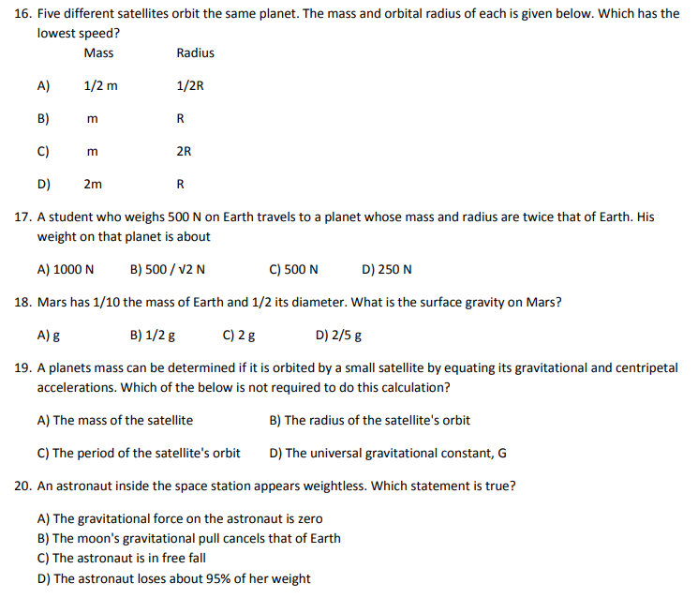
8. You are looking at a top view of a planet orbiting the sun in a clockwise direction. Which of the following would describe the velocity, acceleration, and force acting on the planet due to the Sun’s pull at point P?

